

**Digital Weighing Indicator**

**Instruction Manual**

**Model : CI-5100A**

****

**CONTENTS**

|  |  |  |
| --- | --- | --- |
| **1. Before Installation** | **----------------------------------** | **2 Page** |
| **2. Introduction** | **----------------------------------** | **3 Page** |
| **3. Specification** | **----------------------------------** | **4 Page** |
| **4. Installation** | **----------------------------------** | **10 Page** |
| **5. Set-Up** | **----------------------------------** | **12 Page** |
| **6. Interface** | **----------------------------------** | **34 Page** |
| **7. Error and Treatment** | **----------------------------------** | **50 Page** |
| **8. Warrantee** | **----------------------------------** | **54 Page** |

**1. BEFORE INSTALLATION**

1-1. Caution / Warning Marks

|  |  |
| --- | --- |
| 경_고  Warning | This mark warns the possibility to arrive death or serious injury in case of wrongly used. |
| 주의  Caution | This mark cautions the possibility to arrive serious human body injury or product lose in case of wrongly used. |

1-2. Other Marks

|  |  |
| --- | --- |
| 감전 | Warning for Electric Shock or Damage.  Please do not touch by hand |
| 보호접지 | Protective Ground(Earth) terminal |
| 금지 | Prohibition of Operation process |

1-3. Copy Rights

1). All Right and Authority for this Manual is belonged to CAS.

2). Any kinds of copy or distribution without CAS’s permission will be prohibited.

1-4. Inquiries

If you have any kinds of inquiries for this model, please contact with your local agent or Head Office.

Head Office : CAS.

**2. INTRODUCTION**

2-1. Introduction

Thank you for your choice, this “CI-5100A” Industrial Digital Weighing Indictor..

This “CI-5100A” model is simple application usage Digital Weighing Indicator, with powerful communication performance and High Speed A/D conversion performance will lead you to precise weighing process.

This “CI-5100A” Weighing Indicator is simple application model, and it can be used for most kinds of control applications.

Please review this instruction Manual and learn more about information about

“CI-5100A”.

Enjoy your process efficiency with “CI-5100A” Weighing Indicator.

2-2. Cautions

1). Don’t drop on the ground or avoid serious external damage on item.

**Cautions**

**!**

2). Don’t install under sunshine or heavy vibrated condition.

3). Don’t install place where high voltage or heavy electric noise condition.

4). When you connect with other devices, please turn off the power of item.

5). Avoid from water damage.

6). For the improvement of function or performance, we can change item specification without prior notice or permission.

7). Item’s performance will be up-dated continuously base on previous version’s performance.

2-3. Features

1). All Modules and Option Cards are isolated to maximize accuracy and performance.

2). External input terminal inside.

3). By using “Photo-Coupler” on each module(Option, Analog board, In/Out), we improved “Impedance problem”, “Isolation ability among inputs”, “Leading power problem”, and “Noise covering function”.

4). Data back-up function, when the sudden power off

5). Polycarbonate film panel, strong against dust and water

6). RS-232C (Com. Port1) is standard installed.

7). Variable options(Order in advance)

2-4. Box Contents

1). Power Cable(1pcs) / Fuse(2pcs) / Load cell Connector(1pcs) / Manual(1pcs)

**3. SPECIFICATION**

3-1. Analog Input & A/D Conversion

|  |  |
| --- | --- |
| **Input Sensitivity** | 0.2㎶ / Digit |
| **Load Cell Excitation** | DC 10V ( - 5V ~ + 5V ) |
| **Max. Signal Input Voltage** | Max.32mV |
| **Temperature Coefficient** | [Zero] ±20PPM/℃  [Span] ±20PPM/℃ |
| **Input Noise** | ±0.6㎶ P.P |
| **Input Impedance** | Over 10㏁ |
| **A/D Conversion Method** | Sigma-Delta |
| **A/D Resolution(Internal)** | 520,000 Count(19bit) |
| **A/D Sampling Rate** | Max. 200times / Sec |
| **Non-Linearity** | 0.01% FS |
| **Display Resolution(External)** | **1/30,000** |

3-2. Digital Part

|  |  |  |  |
| --- | --- | --- | --- |
| **Display** | **Parts** | | **Specification** |
| **Display** | Main Display | | 7Segments, 6digits Red color FND  Size :20.0(H) ×13.0(W)mm |
| Min. Division | | ×1, ×2, ×5, ×10, ×20, ×50 |
| Max. display value | | +999,950 |
| Under Zero value | | "-" (Minus display) |
| **Status lamp** | **CI-5100A** | Steady, Zero, Tare, Gross, Auto, Print, Hold, RTxD | Green color Condition display Lamp (8pcs) |
| **K e y** | Number, Function Key | | Number Key, Function (16pcs) |

3-3. General Specification

|  |  |
| --- | --- |
| **Power Supply** | SMPS Free Voltage Power Supply(AC86~265V) |
| **Operating Temperature Range** | -5℃ ~ 40℃ |
| **Operating Humidity Range** | Under 85% Rh (non-condensing) |
| **External Dimension** | 193mm(W)ｘ100mm(H)ｘ140mm(L) |
| **Net Weight(kg)** | About 1.5kg |
| **Gross Weight(kg)** | About 2.5kg |

3-4. Option Card

|  |  |
| --- | --- |
| **Option No.1** | Analogue Output (0~10V) |
| **Option No.2** | Analogue Output (4~20mA) |
| **Option No.3** | Serial Interface : RS422 / RS485 |
| **Option No.4** | BCD Input |
| **Option No.5** | BCD Output |

※ Serial Interface (RS-232C) or Current Loop is Standard installed.

3-5. Front Panel (Display & Key pad) – CI-5100A

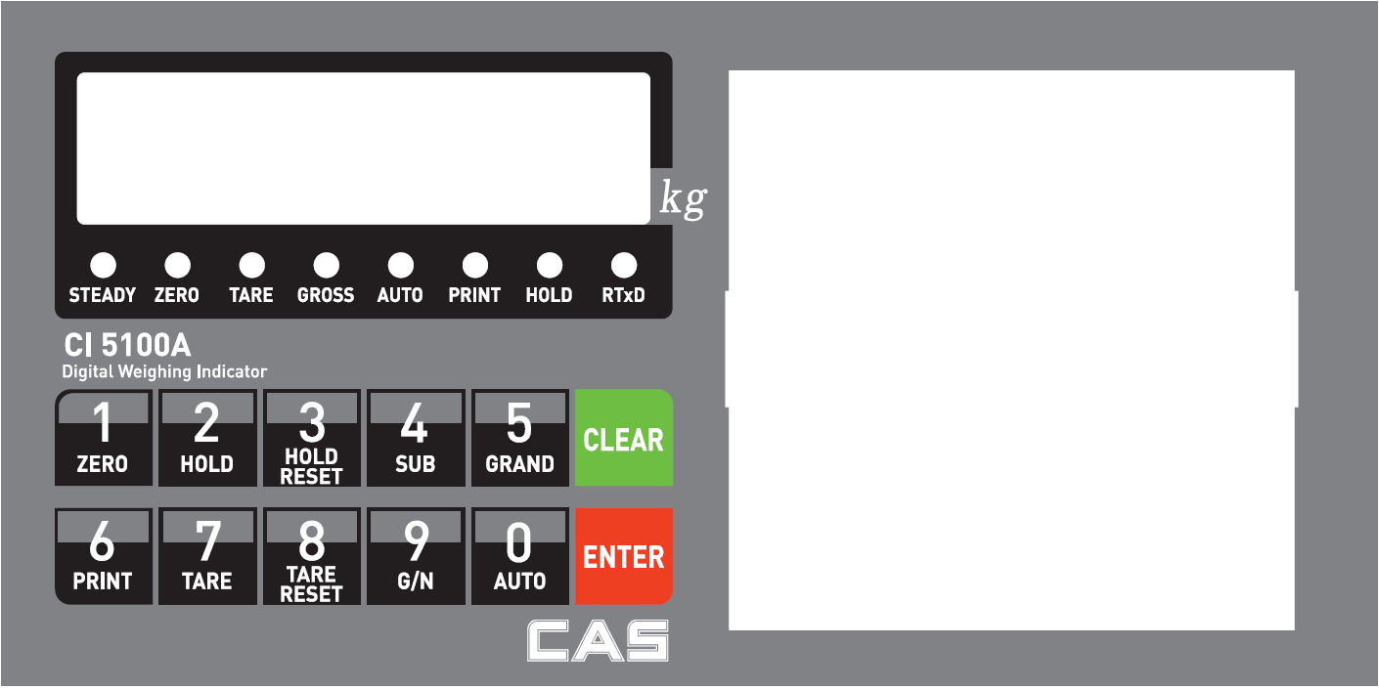

3-5-1. Status Lamp (ANNUNCIATORS) : Green Color Lamp is “ON”. – **CI-5100A**

|  |  |
| --- | --- |
| **Steady** | When the weight is Steady, “▼” Lamp is turn on. |
| **Zero** | When the current weight is Zero, Lamp is turn on.  (Displayed weight is Zero, Lamp is turn on.) |
| **Tare** | Tare function is set, Lamp is turn on.  (Tare Reset 🡪 Lamp is turn off.) |
| **Gross** | Gross Weight Display – Lamp is “ON”  Net Weight Display – Lamp is “OFF”. |
| **Auto** | Auto Printer Mode, Lamp is “ON”. |
| **Print** | Print Data Transfer, Lamp is “ON” |
| **Hold** | Hold Function is SET – Lamp is “ON”. |
| **RTxd** | When indicator transfers or receives data from other devices, Lamp is turn on. (If the Lamp is off although there is some data transference, please check communication settings). |

3-5-2. Key Pad Function – **CI-5100A**

|  |  |
| --- | --- |
| 1.jpg | Make Weight value as Zero.  Under F08, you can set the Zero key operation range, as 2%, 5%, 10%, 20% or 100% of Max. Capacity.  ※ Under “Tare” key input, Zero key will not be activated within operation range. |
| **2.jpg** | Hold the Display Value.  - Through the Function, you can select “Peak”, “Sample”, “Average” Hold Functions. |
| **3.jpg** | TARE RESET  1. Remove the Set TARE function.  - If you press this key, TARE set value will be removed and display gross weight. |
| **4.jpg** | Under Print installation, you can print out the “Sub-total data” of current P/N.  Printed Data : Accumulated count and weight of All P/N. |
| 5.jpg | Under Print installation, you can print out the “Grand-total data” of all P/N.  Printed Data : Accumulated count and weight of All P/N. |
| 6.jpg | **Manual Print**  - When Key input, print output. |
| 7.jpg | Make Weight value as Zero, including Tare Weight.  Under F09, you can set the Tare key operation range, as 10%, 20%, 50%, or 100% of Max. Capacity.  ※ Whenever pressing “Tare” key, you can set the Tare continuously. |
| 8.jpg | TARE RESET  1. Remove the Set TARE function.  - If you press this key, TARE set value will be removed and display gross weight. |
| 9.jpg | Change the Display to Gross Weight 🡪 Net Weight Display Mode. |
| 9.jpg | **Auto Print Mode**  - Weight Data is Steady, Automatic Print Mode  **Calibration mode**  - Digit setting  Whenever pressing “0”key, digit will be change 1, 2, 5, 10, and 50. |
| C.jpg | 1. Modify the set value during setting process.  2. Calibration mode  - Move back to previous step.  3. F-function setting mode  - Change F-function No.  F-function no.(number key) + Clear 🡪 directly move |
| E.jpg | 1. Save set value during setting process.  2. Calibration mode  - Save current setting and move to next step.  3. F-Function mode  - Save current F-function setting, and move to next F-function |

※ Function Keys (Combined Key functions : c.jpg key + other keys) – **CI-5100A**

|  |  |  |
| --- | --- | --- |
| c.jpg | 1.jpg | Time set value check or Change |
| c.jpg | 2.jpg | Date set value check or Change |
| c.jpg | 4.jpg | Sub-Total Data Delete |
| c.jpg | 5.jpg | Grand-Total Data Delete |
| c.jpg | 7.jpg | Part No.(P/N) Check or Change |
| c.jpg | 8.jpg | Code No. Check or Change |
| c.jpg | 9.jpg | Serial No.(S/N) Check or Change. |
| c.jpg | 7.jpg | Set “Key Tare” function (press 8.jpg key for Reset) |

3-6. Rear Panel – **CI-5100A**

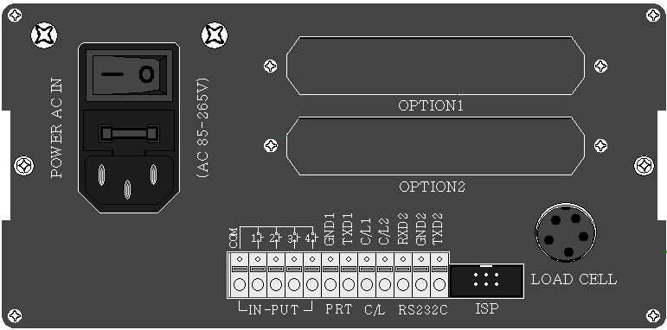

**Option**

**Slot**

**Load Cell**

**Connector**

**ISP**

**Power**

**Comm.**

**Digital Input**

|  |  |
| --- | --- |
| ①POWER | -Power ON/OFF Switch  -Fuse : AC 250V 2A  -AC IN : AC86~265V Power In |
| ②OPTION 1,2 | - OPTION BOARD install slot.  - ANALOG out, Serial I/F, etc |
| ③LOAD CELL  CONNECTOR (N-16) | -EXC + (+5V) PIN1 (RED)  -EXC - (-5V) PIN2 (WHITE)  -SIG+ PIN3 (GREEN)  -SIG- PIN4 (BLUE)  -SHIELD PIN5 (SHEILD) |
| ④Digital Input | - Digital Input Signal terminal  Refer to “F-function 11”. |
| ⑤Output Terminal | -RS-232C/CURRENTLOOP (Standard Installed) ( GND,TXD1,CL1,CL2,RXD,GND,TXD ) |
| ⑥ISP  (Digital Lock Pin) | - Insert “Lock Pin Header”, to protect “F-function” data and other settings from Electric Noise effect.  - To change the setting, please remove the “Lock Pin Header”. |

4. INSTALLATION

4-1. External Dimension & Cutting Size

(External Dimension) (unit : mm)

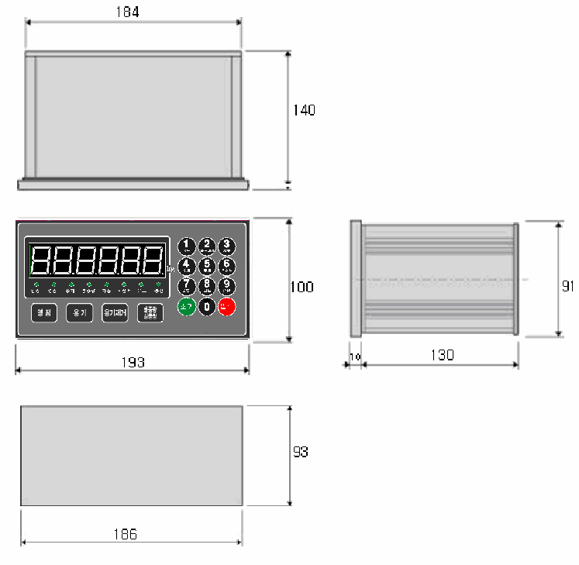

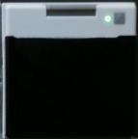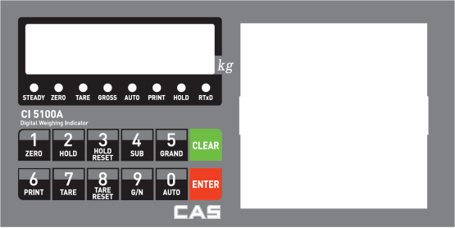

**Cutting Size**

4-2. Formula to plan the precise weighing system

This “CI-5100A” weighing controller’s Max. input sensitivity is **0.2㎶ / Digit**.

**Cautions**

**!**

And for precise weighing system, the following formula must be satisfied.

**Caution** : “Input sensitivity” means Min. output voltage variation of weighing part to change 1digit. So, please do not make large input voltage to make reliable weighing system.

|  |  |  |  |
| --- | --- | --- | --- |
| Single Load cell use |  | ≤EⅹBⅹD | A : Load cell capacity(kg)  B : Load cell Voltage(mV)  D : Digit  E : affirmation Voltage of Load cell  N : Number of Load cell |
| 0.2㎶ | A |
|  |
| Plural Load cells use |  | ≤EⅹBⅹD |
| 0.2㎶ | AⅹN |
|  |

Example1.)

Number of Load cell : 1pcs

Load cell capacity : 500kg

Load cell Voltage : 2mV/V

Digit : 0.05kg

Affirmation Voltage of Load cell : 5.0V

Max. Capacity of Weighing System : 300kg

Then, estimation result for this weighing system with formula,

|  |  |  |
| --- | --- | --- |
| 5000ⅹ2ⅹ0.05 | = 1 ≥ 0.2㎶ | The calculated value is larger than 0.2㎶, so this system has no problem. |
| 500 |

Example2.)

Number of Load cell : 4pcs

Load cell capacity : 500kg

Load cell Voltage : 2mV/V

Digit : 0.10kg

Affirmation Voltage of Load cell : 5.0V

Max. Capacity of Weighing System : 1,000kg

Then, estimation result for this weighing system with formula,

|  |  |  |
| --- | --- | --- |
| 5000ⅹ2ⅹ0.10 | = 0.5 ≥ 0.2㎶ | The calculated value is larger than 0.2㎶, so this system has no problem. |
| 500ⅹ4 |

**5. SET-UP**

5-1. Calibration

Adjust weight balance between “Real weight” on the load cell(Weight Part) and “Displayed weight of Indicator”. When you replace LOAD CELL or Indicator, you have to do Calibration process once again

5-2. Test Weight Calibration

Prepare At least 10% of Max. capacity of your weighing scale

**Step 1. Enter Calibration Mode**

**회색.png회색.png검은색.png검은색.png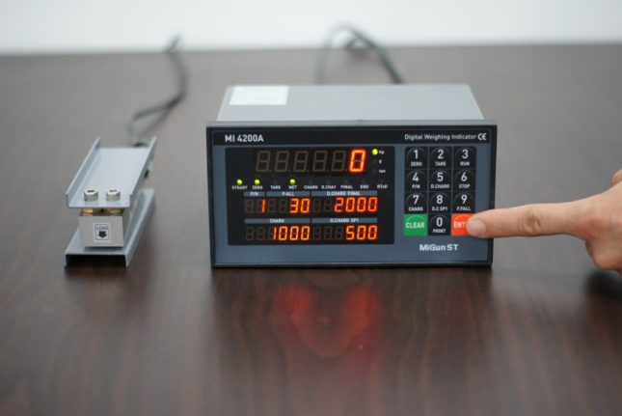 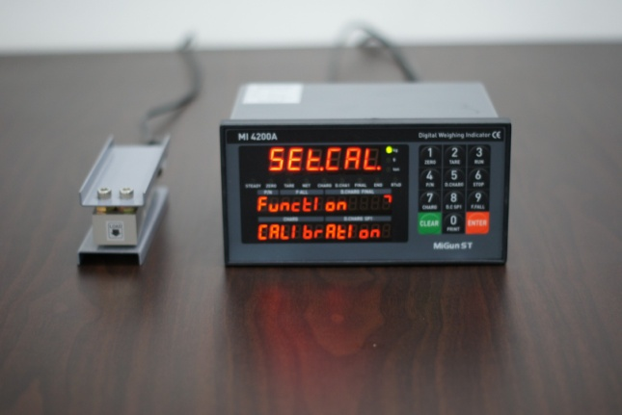**

**회색.png회색.png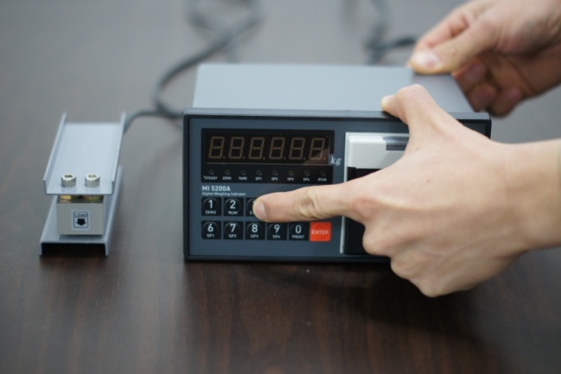 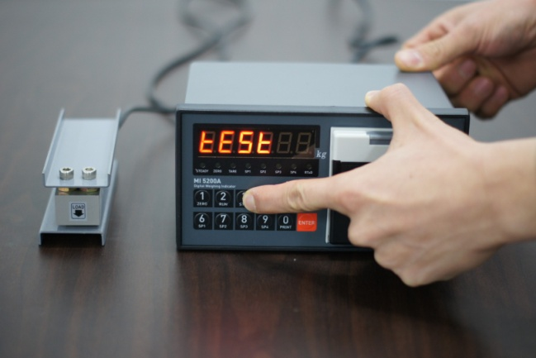**

**회색.png회색.png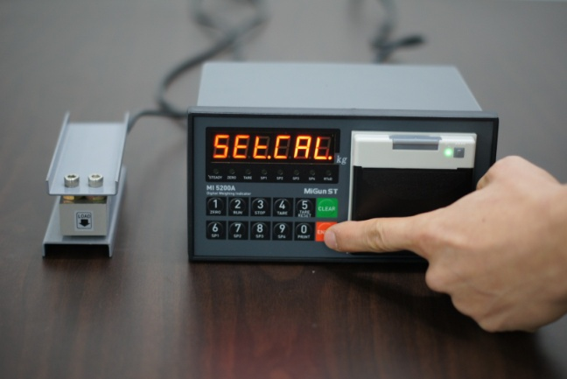**

Press **e.jpg** **key** during 5 sec 🡪 display.

SET-CAL

Or turn on the Power + with pressing 3.jpg 🡪 display

TEST

Press E.jpg key to start “Calibration Mode”.

**Remarks : Go to next step with saveE.jpgkey / Back to previous step c.jpgkey.**

**Step 2. Digit(Division)setting ( display)**

d \_1

**회색.png회색.png회색.png회색.png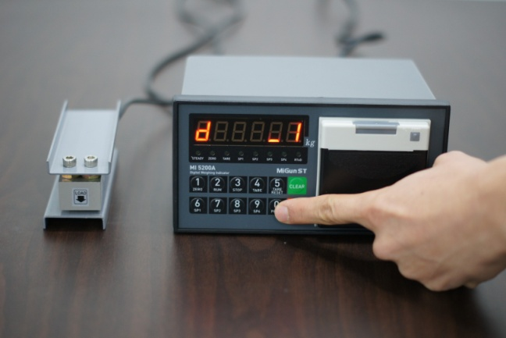 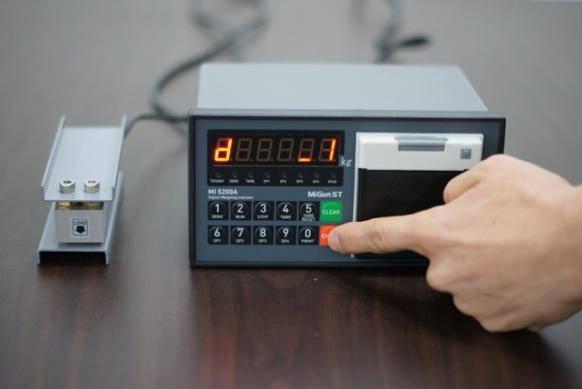**

Press 0.jpgkey and stop the optimal Digit value.

(Whenever pressing 0.jpgkey, digit value will be changed, like 01-02-05-10-20-50)

Press E.jpgkey and save change and move to next step.

**Step 3. Max. Capacity Setting ( 🡪 display)**

CAPA

XXXXXX

**회색.png회색.png회색.png회색.png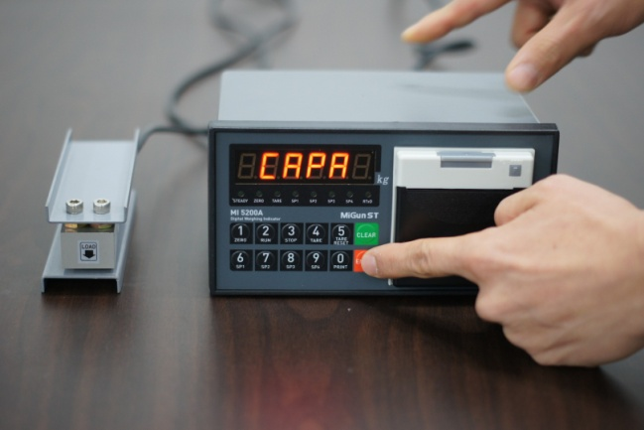 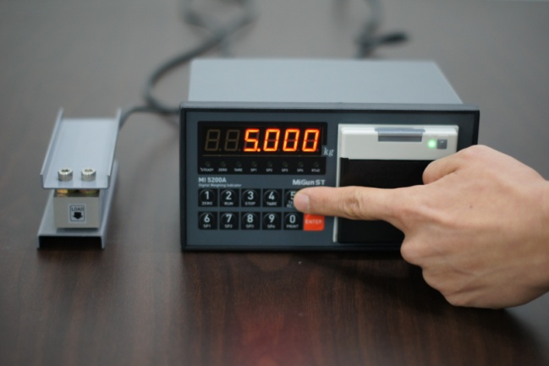**

**회색.png회색.png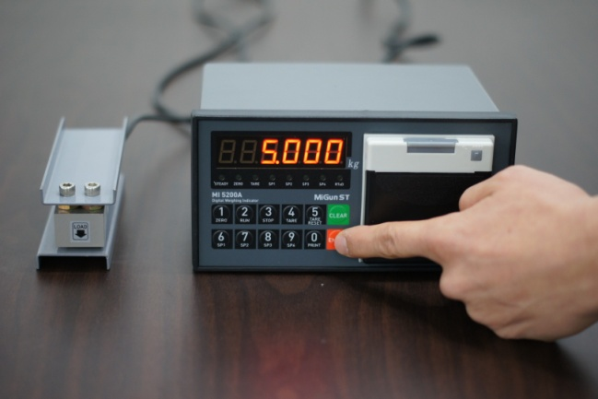**

Input Max. Capacity of Scale with No. keys.

Input Capacity and press **E.jpg** key, and move to next step.

**※ Caution**

**(Max. capacity value / division value)** can not be over **30,000**.(as Indicator resolution is 1/30,000).

**Step 4. Zero Balance setting ( display)**

CAL \_0\_

**회색.png회색.png회색.png회색.png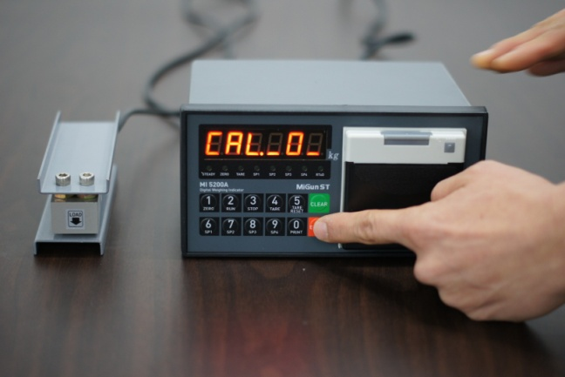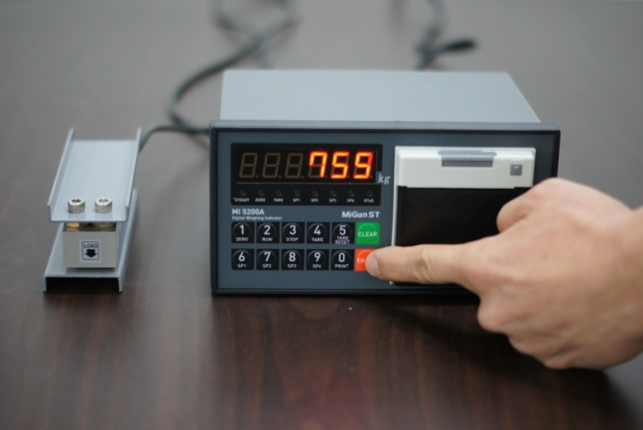**

**회색.png회색.png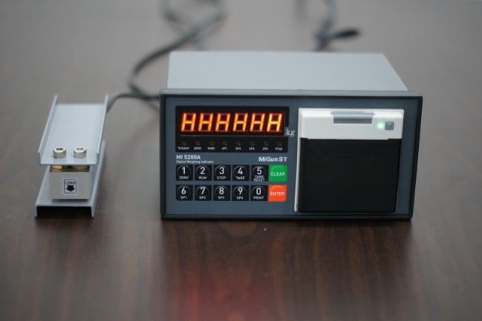**

Make empty the scale part, and press **E.jpg** key.

Indicator check the current Zero balance and save the value and move next step.

**Step 5. Span value calculation (🡪🡪)**

SPAN

XXXXX

C\_UP\_

**회색.png회색.png회색.png회색.png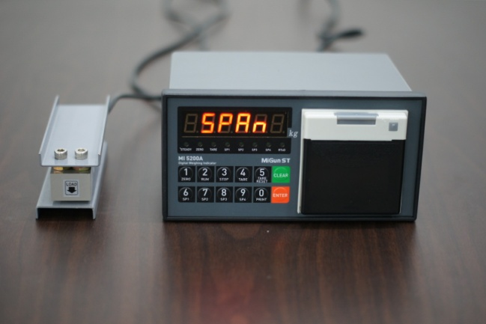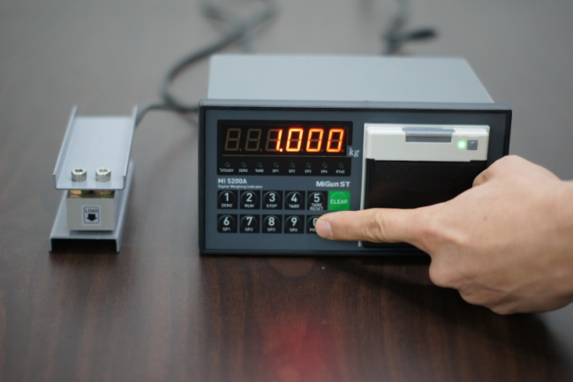**

**회색.png회색.png회색.png회색.png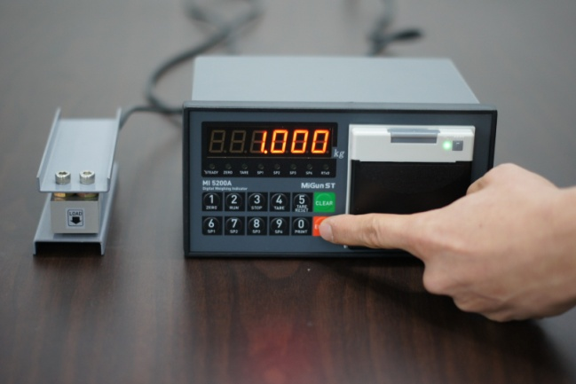 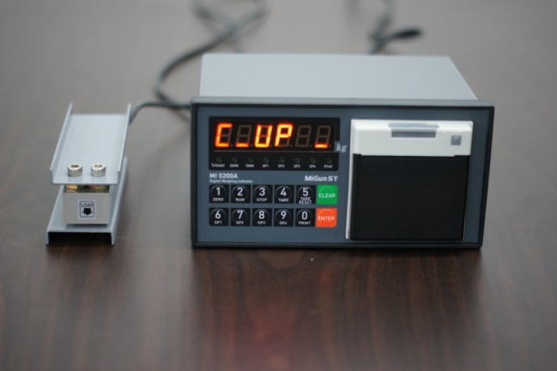**

**회색.png회색.png회색.png회색.png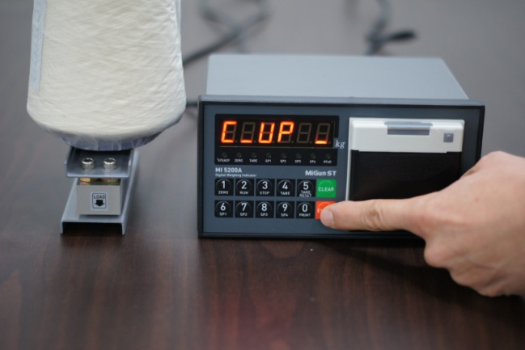 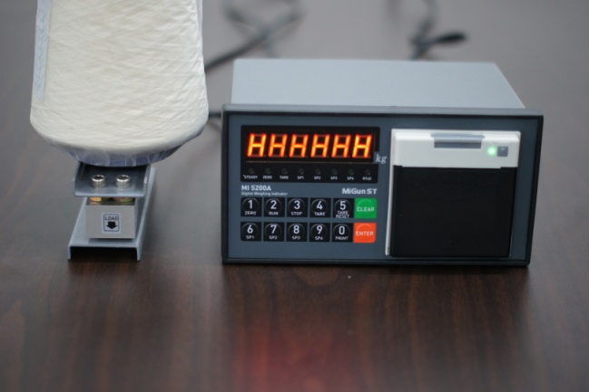**

Input prepared Test weight value with No. keys.

And press **E.jpg** key.

Then, display will show and then, load prepared test weight unit on the scale.

C\_UP\_

After a few seconds(to remove the vibration effect), press **E.jpg** key.

Then, indicator will calculate Span value and move the next step.

**※ Caution**

**For the precise Span calibration, please prepare Test weight unit, at least 10% of Max. capacity of Scale.**

**Step 6. Check Span Value and Finish the Calibration (**🡪**)**

XXXXXX

C-END

**회색.png회색.png회색.png회색.png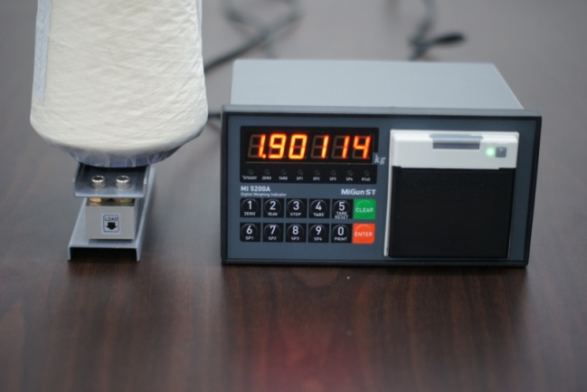 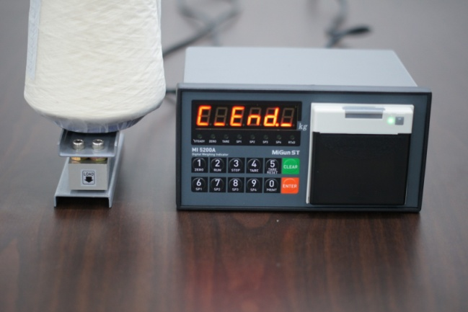**

**회색.png회색.png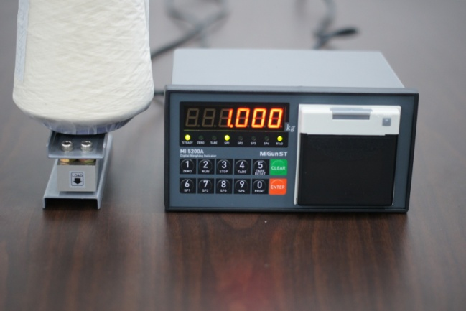**

Check the Calculated Span value.

And after 3sec, will displayed automatically and move to weighing Mode.

C-END

5-3. Simulation Calibration Mode (Without Test Weight)

**- This calibration Method will be useful to make calibration more than 10ton capacity setting.**

**- Guaranteed resolution will be 1/5,000 and if you need higher resolution, please make calibration with Test weight.**

**Step 1. Enter to the “SET-CAL” mode**

**회색.png검은색.png검은색.png **

**회색.png검은색.png회색.png검은색.png 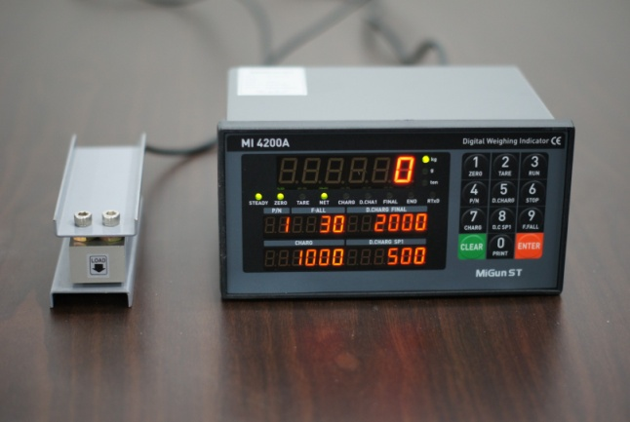 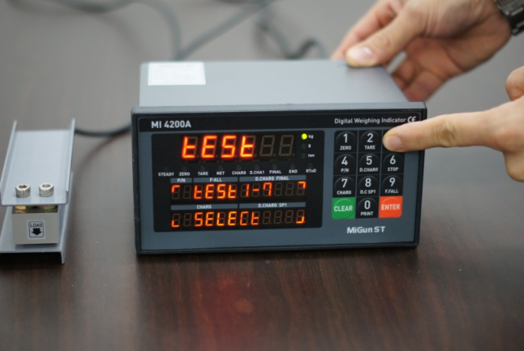**

**회색.png검은색.png회색.png검은색.png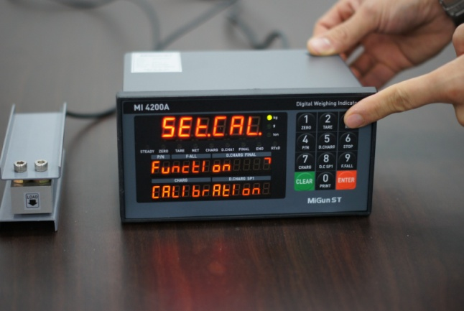 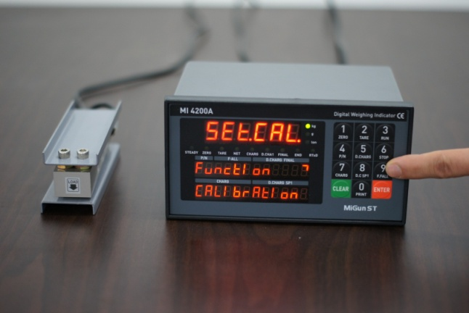**

Press **e.jpg** **key** during 5 sec 🡪 display.

SET-CAL

Or turn on the Power + with pressing 3.jpg 🡪 display

TEST

Press 3.jpg key 🡪 display.

SET-CAL

Press  key to start “Simulation Calibration Mode”.

**Remarks : Go to next step with savee.jpgkey / Back to previous step c.jpg key Step 2.**

**Step 2. Digit (Division)setting (**🡪  **display)**

CAL\_ \_2 \_1

d \_ 1

**회색.png검은색.png회색.png검은색.png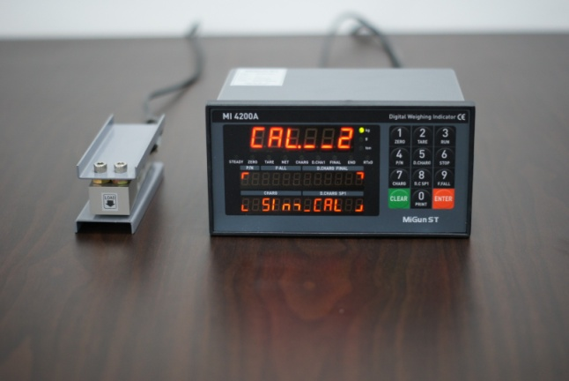 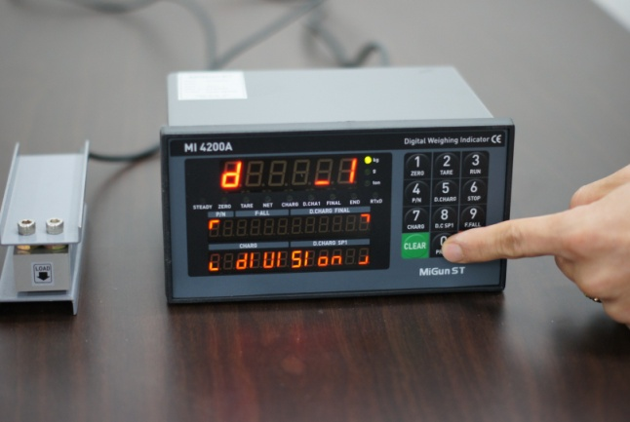**

**검은색.png회색.png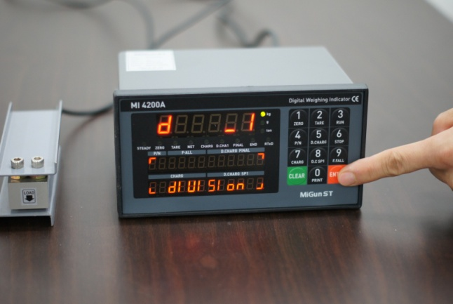**

Press 0.jpgkey and stop the optimal Digit value.

(Whenever pressing 0.jpgkey, digit value will be changed, like 01-02-05-10-20-50)

Press e.jpgkey and save change and move to next step.

**Step 3. Max. Capacity of Load cell ( 🡪 display)**

CAPA

XXXXXX

회색.png검은색.png회색.png검은색.png **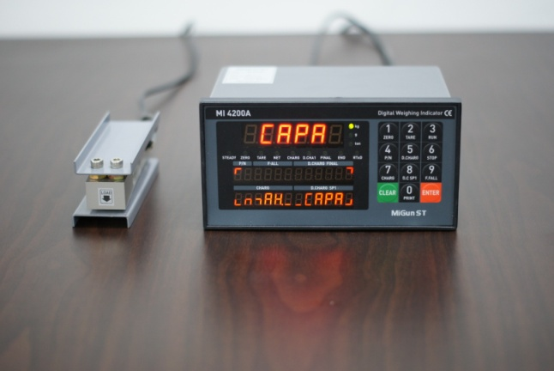** **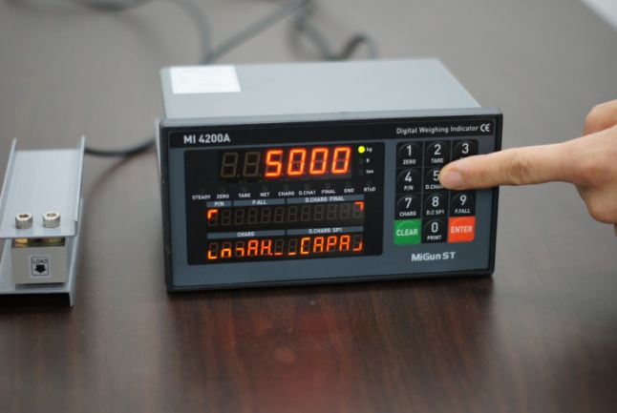**

Input Max. Capacity of Scale with No. keys.

- Under this step, input Total sum of each load cell’s Max. Capacity. (Not weighing Scale)

- The Max. Capacity of load cell is stated on **“Test report”** or **“Label”**.

- If you installed 4 load cells, and each load cell’s Max. Capacity is 500kg, then you have to input 2,000kg, as a Max. Capacity.

Input Capacity and press **e.jpg** key, and move to next step.

**Step 4. Measure/Adjustment optimal Zero balance of Scale ( display)**

CAL \_0\_

**검은색.png회색.png검은색.png회색.png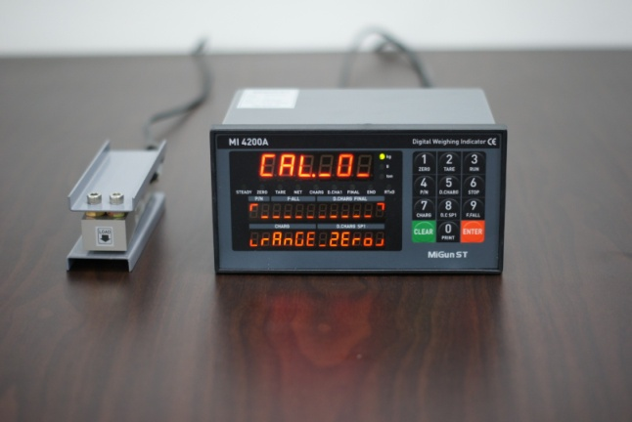 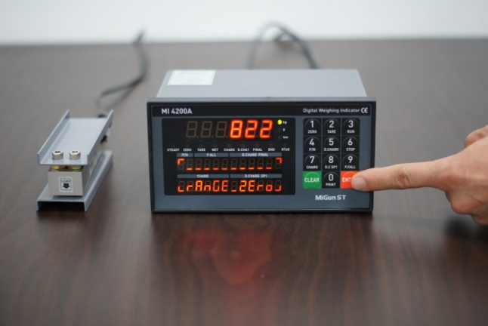**

Make empty the scale part, and press **e.jpg** key.

Indicator check the current Zero balance and save the value and move next step.

**Step 5. Input Max. Output Rate (mV/V) value of load cell**

**검은색.png회색.png검은색.png회색.png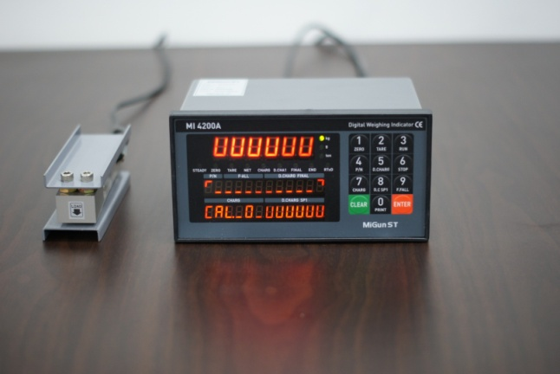 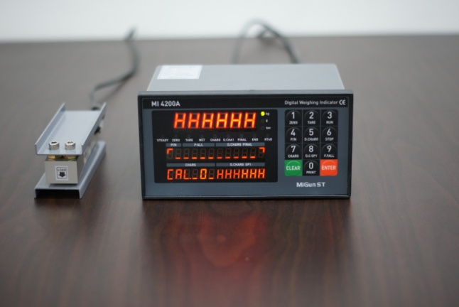**

**검은색.png회색.png검은색.png회색.png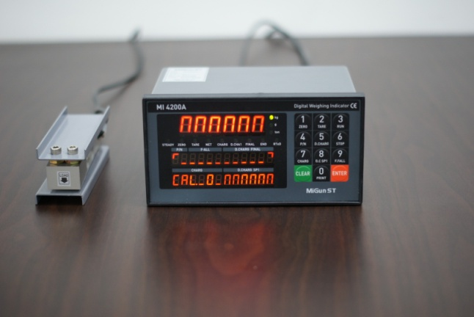 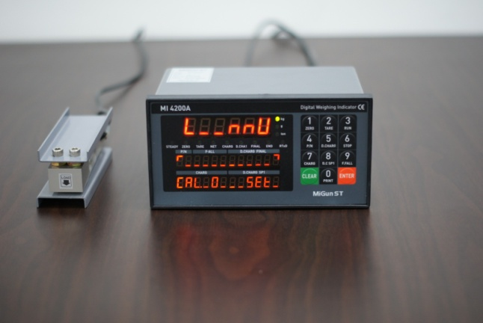**

**검은색.png회색.png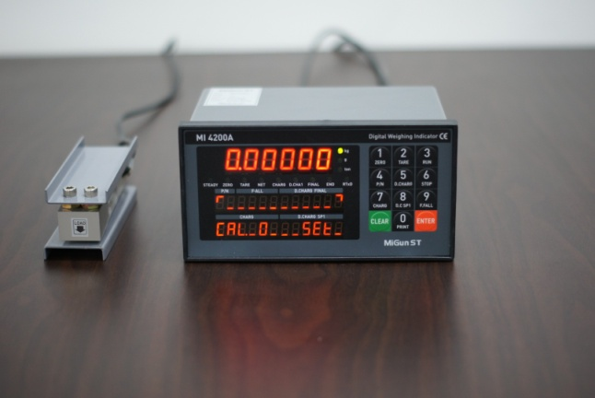 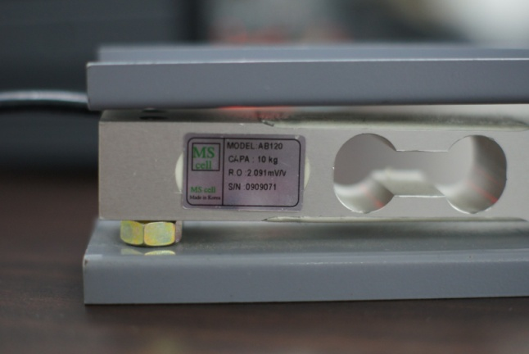**

**회색.png검은색.png회색.png검은색.png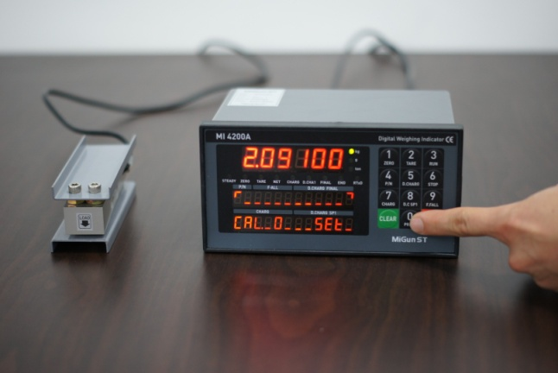 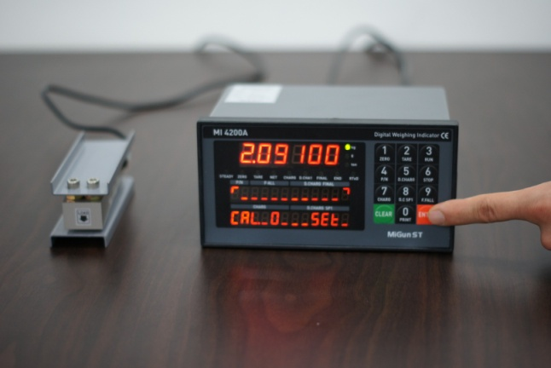**

Input Max. Output Rate(mV/V) value of load cell with No. keys.

- Under this step, input Max. Output rate(mV) of load cell.

- If you installed a few pieces of load cells, the connection will be parallel, so the rated output of a few load cells are as same as single load cell’s rated output.

- The Output rate is stated on “Test report” or “Label”

And press **e.jpg** key.

**Step 6. End Calibration and Auto Reset**

**검은색.png회색.png검은색.png회색.png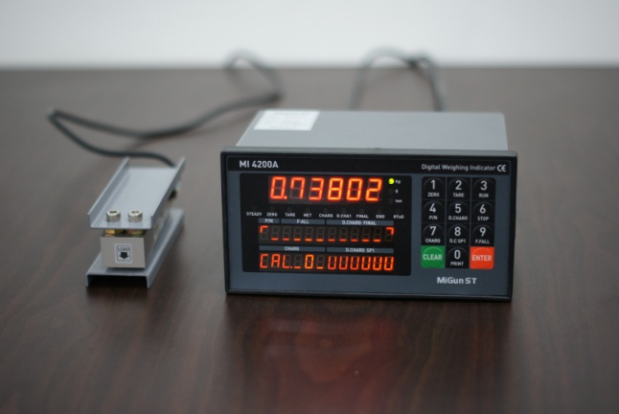 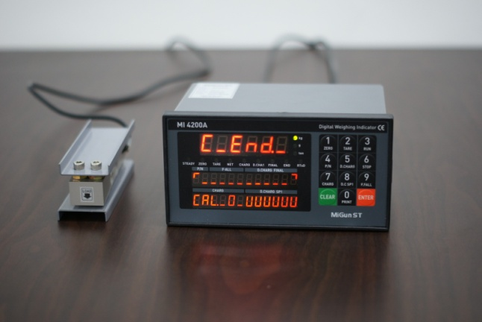**

- Calculated Span value will be displayed and automatically reset and move the normal weight indicating mode.

5-4. Function Setting

To make more accuracy performance through this Function setting.

**Step 1. Enter to Function setting mode.**

**회색.png회색.png **

**회색.png회색.png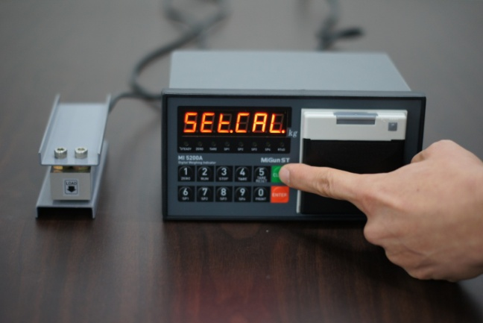**

Turn on the Power + 3.jpg 🡪 display

TEST

Press 3.jpg key 🡪 display

SET-CAL

Press c.jpg key to start **“F-function Mode”**.

**Step 2. Change the F-Function No.**

**회색.png회색.png회색.png회색.png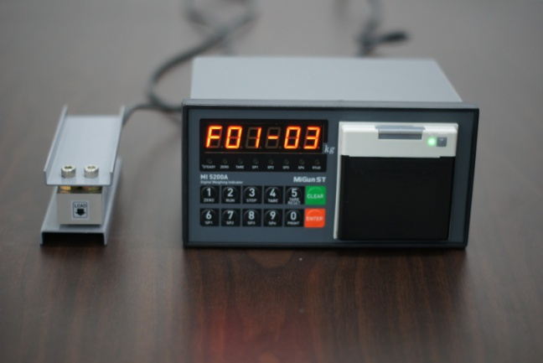 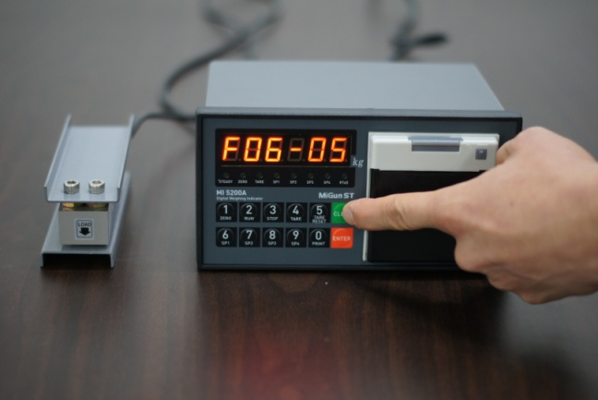**

To change the F-function No., press c.jpg key.

Whenever pressing c.jpg key, Function No. will be changed

If you want to move certain function No. directly, press function No. with keypad and press c.jpg key.

**Step 3. Change the Set value.**

**회색.png회색.png회색.png회색.png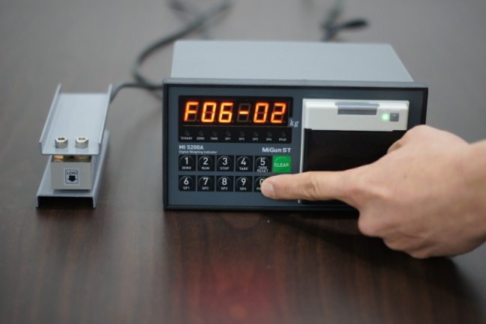 **

Input new set value with keypad, and press E.jpg key to save new setting.

If you don’t press E.jpg key, after changing the set value, the new set value will not be saved.

**Step 4. Exit from Function setting mode.**

**회색.png회색.png회색.png회색.png 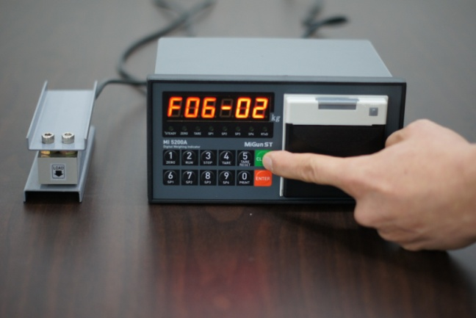**

**회색.png회색.png회색.png회색.png 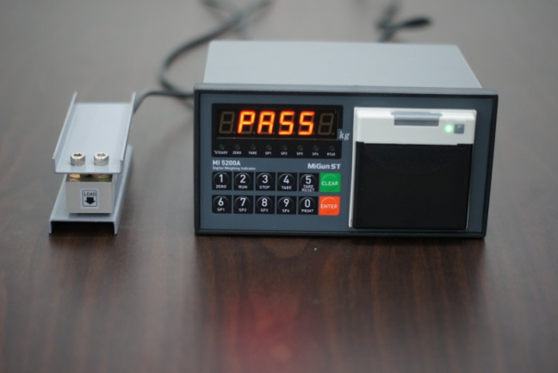**

Press 0.jpg + c.jpg + 0.jpg key to exit function mode.

5-5. Function List – CI-5100A

|  |  |  |
| --- | --- | --- |
| **Function**  **No.** | **Contents** | **Remark** |
| F00 | Set-up / Calibration Mode Selection | Set-up : Clear key  Calibration : Enter key |
| F01 | Decimal point setting | Setting range : 0~3 |
| F02 | Back up mode selection | Setting range : 0, 1 |
| F03 | Motion Band setting | Setting range : 0~9 |
| F04 | Zero Tracking setting | Setting range : 0~9 |
| F05 | Auto Zero Range setting | Setting range : 00~99 |
| F06 | Digital Filter setting | Setting range : 00~49 |
| F07 | Zero / Tare key activating setting | Setting range : 0, 1 |
| F08 | Zero key operating range setting | Setting range : 0~4 |
| F09 | Tare key operating range setting | Setting range : 0~3 |
| F10 | Hold Function setting | Setting range : 0~4 |
| F11 | Digital Input setting | Setting range : 0~7 |
| F12 | Code No. Setting | Setting range : 0~2 |
| F13 | S/N key Operating Selection | Setting range : 0, 1 |
| F14 | Hold Off time setting | Setting range : 0.0~9.9sec |
| F30 | Serial I/F Parity Bit setting | Setting range : 0~2 |
| F31 | Serial I/F Communication Speed setting | Setting range : 0~9 |
| F32 | Serial I/F Mode setting | Setting range : 0~2 |
| F33 | Serial I/F Transference Method setting | Setting range : 0~5 |
| F34 | ID Number setting | Setting range : 01~99 |
| F35 | Transferred Data Format | Setting range : 0~2 |
| F36 | BCC selection mode | Setting range : 0, 1 |
| F37 | Data Transferring count setting Port No.1) | Setting range : 0~6 |
| F50 | Weight Unit Selection (Printer) | Setting range : 0~2 |
| F51 | When Automatically print, Data output selection | Setting range : 0, 1 |
| F52 | Print format selection | Setting range : 0, 1 |
| F53 | Sub-Total Data delete Selection | Setting range : 0, 1 |
| F54 | Paper withdraw rate Selection | Setting range : 0~9 |
| F55 | Print Line interval Selection | Setting range : 0~9 |
| F56 | Sub-Total Print Mode Selection | Setting range : 0, 1 |
| F57 | Print Language Selection | Setting range : 0, 1 |
| F58 | Print Delay time selection | Setting range : 0.0 ~ 9.9 |
| **Function**  **No.** | **Contents** | **Remark** |
| F60 | BCD output Selection | Setting range : 0, 1 |
| F63 | Average Value Display Selection | Setting range : 00~99 |
| F64 | Steady LED Status Lamp Delay time setting | Setting range : 0.0~9.9sec |
| F65 | Tension and Compression setting | Setting range : 0, 1 |
| F80 | Empty Range | Setting range : 0~Max. Capa |
| F81 | Zero Range Setting | Setting range : 0~Max. Capa |
| F83 | Analogue output setting | Under option installed |
| F89 | Span Value check |  |
| F90 | Date check / change |  |
| F91 | Time check / change |  |

5-6. Function List detailed information.

|  |  |  |  |  |  |  |  |  |  |  |  |  |  |
| --- | --- | --- | --- | --- | --- | --- | --- | --- | --- | --- | --- | --- | --- |
| **Set-Up / Calibration Mode Selection** | | | | | | | | | | | | | |
| F00 | |  | | | Clear | | | | Set-Up mode | | | | |
|  | | | Enter | | | | Calibration Mode | | | | |
| **Decimal Point Setting** | | | | | | | | | | | | | |
| F01 | | ● | | | 0 | | | | No Decimal point | | | | |
|  | | | 1 | | | | 1st place under Zero (0.0) | | | | |
|  | | | 2 | | | | 2nd place under Zero (0.00) | | | | |
|  | | | 3 | | | | 3rd place under Zero (0.000) | | | | |
| **Back up mode selection** | | | | | | | | | | | | | |
| F02 | | ● | | | 0 | | | | Normal mode | | | | |
|  | | | 1 | | | | Back up mode | | | | |
| **Motion Band Range setting** | | | | | | | | | | | | | |
| F03 | | 5 | | 0  ∫  9 | | | | This is set “Steady” acceptable range of weighing part.  If there is vibration on weighing part, you can set this function and reduce the vibration effect on weighing process.  0 : Weak vibration  ∫  9 : Strong Vibration | | | | | |
| **Zero Tracking Compensation Range setting** | | | | | | | | | | | | | |
| F04 | | 5 | | 0  ∫  9 | | | | Due to external causes(Temperature, wind, and dust), there are small weight difference, indicator will ignore the weight difference and display Zero.  For this compensation function, indicator will estimate the weight difference is over the set range during fixed time period.  If there is large weight difference over set range within fixed time period, the “Zero” is breaking and will find new zero point. | | | | | |
| **Auto Zero Range setting** | | | | | | | | | | | | | |
| F05 | | 00 | | 00  ∫  99 | | | | Within the “Auto Zero” range, weighing part is steady, indicator will display current weight as “Zero”  If the weighing part is not “Steady”, indicator will display current weight.  (Auto Zero Range : ± Set value + weight unit) | | | | | |
| **Digital Filter setting** | | | | | | | | | | | | | |
| F06 | 15 | | 00  ∫  49 | | | | Small set value for weak vibration  Large set value for strong vibration | | | | | Small set value more sensitive | |
| **Zero /Tare key Operation mode selection** | | | | | | | | | | | | | |
| F07 | | ● | | | 0 | | | | Activate when “Steady” condition, only | | | | |
|  | | | 1 | | | | Always activated | | | | |
| **Zero key Operation Range selection** | | | | | | | | | | | | | |
| F08 | |  | | | 0 | | | | Activated within 2% of Max. Capacity | | | | |
|  | | | 1 | | | | Activated within 5% of Max. Capacity | | | | |
|  | | | 2 | | | | Activated within 10% of Max. Capacity | | | | |
| ● | | | 3 | | | | Activated within 20% of Max. Capacity | | | | |
|  | | | 4 | | | | Activated within 100% of Max. Capacity | | | | |
| **Tare key Operation Range selection** | | | | | | | | | | | | | |
| F09 | |  | | | 0 | | | | Activated within 10% of Max. Capacity | | | | |
|  | | | 1 | | | | Activated within 20% of Max. Capacity | | | | |
|  | | | 2 | | | | Activated within 50% of Max. Capacity | | | | |
| ● | | | 3 | | | | Activated within 100% of Max. Capacity | | | | |
| **“Hold” Mode selection** | | | | | | | | | | | | | |
| F10 | | ● | | | 0 | | | | Peak Hold : Measure Max. weight value and hold on display. | | | | |
|  | | | 1 | | | | Sample Hold : Hold current weight until “Hold Reset”. | | | | |
|  | | | 2 | | | | Average Hold : Make average during 3sec, and hold display | | | | |
|  | | | 3 | | | | Average Hold : Make average during 5sec, and hold display | | | | |
|  | | | 4 | | | | Average Hold : Make average during 8sec, and hold display | | | | |
| **External Input Selection** | | | | | | | | | | | | | |
| F11 | **Set Value** | | | | | | | | **Input 1** | **Input 2** | **Input 3** | | **Input 4** |
| ● | | | | | 0 | | | Zero | TARE | TARE RESET | | Print |
|  | | | | | 1 | | | Zero | TARE/RESET | HOLD | | HOLD RESET |
|  | | | | | 2 | | | Zero | TARE/RESET | SUB-Total | | Print |
|  | | | | | 3 | | | Zero | HOLD | HOLD RESET | | Print |
|  | | | | | 4 | | | Zero | SUB-Total | GRAND-Total | | Print |
|  | | | | | 5 | | | Zero | TARE | TARE RESET | | Net/Gross Weight |
|  | | | | | 6 | | | Zero | Print | SUB-Total | | SUB TOTAL DELETE |
|  | | | | | 7 | | | Zero | Print | GRAND-Total | | GRAND TOTAL DELETE |
| **Code No. setting** | | | | | | | | | | | | | |
| F12 | | ● | | | 0 | | | | Fixed Code No. | | | | |
|  | | | 1 | | | | Increase Code No., whenever finish one weighing process | | | | |
|  | | | 2 | | | | Decrease Code No., whenever finish one weighing process | | | | |
| **Serial No. key Operating Selection** | | | | | | | | | | | | | |
| F13 | | ● | | | 0 | | | | S/N key Activate – Use S/N key function | | | | |
|  | | | 1 | | | | S/N key Deactivate – Not use S/N key function | | | | |
| **Hold “Off” time setting** | | | | | | | | | | | | | |
| F14 | | 00 | | | 00  ∫  99 | | | | Time setting of the “Hold Off”  After set time, Hold function will be off automatically. | | | | |

**Communication setting**

|  |  |  |  |  |  |  |  |  |
| --- | --- | --- | --- | --- | --- | --- | --- | --- |
| **Parity Bit selection Mode** | | | | | | | | |
| F30 | ● | | 0 | | | No Parity | | |
|  | | 1 | | | Odd Parity | | |
|  | | 2 | | | Even Parity | | |
| **Serial Communication Speed selection** | | | | | | | | |
| F31 |  | | 0 | | | 115,200bps | | |
|  | | 1 | | | 76,800bps | | |
|  | | 2 | | | 57,600bps | | |
|  | | 3 | | | 38,400bps | | |
|  | | 4 | | | 28,800bps | | |
|  | | 5 | | | 19,200bps | | |
|  | | 6 | | | 14,400bps | | |
| ● | | 7 | | | 9,600bps | | |
|  | | 8 | | | 4,800bps | | |
|  | | 9 | | | 2,400bps | | |
| **Serial I/F Mode setting (Under F33-00 setting, only)** | | | | | | | | | |
| F32 | | ● | | 0 | | | Steam Mode : Continuous Data transfer | | |
|  | | 1 | | | Finish Mode : Single time data transfer, when the weight is finish  - When Finish Relay output, Data will be output. | | |
|  | | 2 | | | Print Mode : Single time data transfer, when print key input | | |
| **Serial I/F Transference method setting** | | | | | | | | | |
| F33 | | ● | | 0 | | | Simplex Mode | | |
|  | | 1 | | | Duplex Mode / Command Mode | | |
|  | | 2 | | | LCD Mode | | |
|  | | 3 | | | Not Use | | |
|  | | 4 | | | External Display Mode | | |
|  | | 5 | | | Not Use | | |
| **ID No. setting** | | | | | | | | | |
| F34 | | 01 | | 01  ∫  99 | | | ID No. setting with No. key.  (01 ~99 settable) | | |
| **Transferred Data Format** | | | | | | | | | |
| F35 | | ● | | 0 | | | Format 1. | | |
|  | | 1 | | | Format 2. (Format 1 + time) | | |
|  | | 2 | | | Format 3. | | |
| **BCC Selection Mode** | | | | | | | | | |
| F36 | | ● | | | 0 | | | BCC not use | |
|  | | | 1 | | | BCC Use | |

|  |  |  |  |
| --- | --- | --- | --- |
| **Data Transference count setting – Port 1(Standard)** | | | |
| F37 |  | 0 | About 40times/sec |
|  | 1 | About 30times/sec |
|  | 2 | About 20times/sec |
| ● | 3 | About 15times/sec |
|  | 4 | About 10times/sec |
|  | 5 | About 5times/sec |
|  | 6 | About 3times/sec |

**Serial Printer Setting (PRT)**

|  |  |  |  |  |  |  |  |  |
| --- | --- | --- | --- | --- | --- | --- | --- | --- |
| **Weight Unit selection (Printer)** | | | | | | | | |
| F50 | | ● | | | 0 | | | kg |
|  | | | 1 | | | g |
|  | | | 2 | | | t |
| **When Automatically print, Data output selection** | | | | | | | | |
| F51 | ● | | 0 | | | When weight reached Empty Range(F80 set value), Automatically print.  - Check Empty Range | | |
|  | | 1 | | | Over than Empty Range, Steady Lamp is “ON”, Automatically Print.  - Will not check Empty Range | | |
| **Print Format selection** | | | | | | | | |
| F52 | | ● | | 0 | | | **Continuous Print**  Serial No. and Weight will be printed continuously. | |
|  | | 1 | | | **Single Print**  Date, Time, S/N, ID No. Weighing Data will be print | |
| **SUB/GRAND Total Data Delete selection** | | | | | | | | |
| F53 | | ● | | | 0 | | | **Manual Delete Mode**  SUN Total Delete : “Clear” key + “SUB” key  GRAND Total Delete : “Clear” key + “GRAND” key |
|  | | | 1 | | | **Automatic Delete Mode**  After SUB/GRAND Total Print, Automatically Deleted. |
| **Paper Withdraw Rate setting (After Finish Printing process)** | | | | | | | | |
| F54 | | 4 | | | 0  ∫  9 | | | Whenever set value increased, 1line will be added. |
| **Printer Line Interval Selection (Only for Continuous Printer format)** | | | | | | | | |
| F55 | | 1 | | | 0  ∫  9 | | | Whenever set value increased, 1line will be added. |
| **SUB Total Print Mode Selection** | | | | | | | | |
| F56 | | ● | | | 0 | | | Normal Mode |
|  | | | 1 | | | Normal Mode + Average total value print |
| **Printing Language Selection** | | | | | | | | |
| F57 | ● | | 0 | | | KOREAN | | |
|  | | 1 | | | ENGLISH | | |
| **Print Delay time Setting** | | | | | | | | |
| F58 | | 00 | | | 00  ∫  99 | | | 00 : No Delay time  99 : 9.9sec later, print output |
| **BCD output Selection** | | | | | | | | |
| F60 | ● | | 0 | | | Positive output | | |
|  | | 1 | | | Negative output | | |
| **Average Value Display Selection** | | | | | | | | |
| F63 | 00 | | 00  ∫  99 | | | 00 : Not Use Average Display  99 : High Set value could be caused late display speed. | | |

|  |  |  |  |
| --- | --- | --- | --- |
| **Steady LED Status Lamp Delay time setting** | | | |
| F64 | 00 | 00  ∫  99 | 00 setting : No delay for the Steady LED lamp  99 setting : Delay during 9.9sec, and LED lamp will be ON. |
| **Tension and Compression setting** | | | |
| F65 | ● | 0 | Not Use (JP1 switch OFF at main board) |
|  | 1 | Use (JP1 switch ON at main board and then must be re-calibration) |

**Other Setting**

|  |  |  |  |  |
| --- | --- | --- | --- | --- |
| **EMPTY Range setting** | | | | |
| F80 | X.X.X.X.X.X.  (0.0.0.0.1.0) | | You can set “EMPTY” Range.  Within set range, indicator will not display current weight and just display “Zero”.  “0.000” setting : When Net Zero, “Zero” status lamp and Near Zero relay will be output.  “0.190” setting : Within 190, “Zero” Status lamp and Near Zero relay will be output. | |
| **Zero Range setting** | | | | |
| F81 | | XXXXXX | | Within this “Zero Range setting”, all the weight value will be displayed, As “0” |
| **Analogue Output Setting (only for the analogue option installation)** | | | | |
| F83 | | XXXXXX | | At the set weight value, analogue output will be maximized.  Ex.) Set 5000, then a weight reached 5000 🡪 20mA or 10V will be output  But if you need just 3000 of Max. capa, you can input 3000 through this function, then the weight reached 3000 🡪 20mA or 10V will be output |
| **Span Value Check** | | | | |
| F89 | | XXXXXX | | At this function, you can check the Calculated Span value.  ※ If you have difficulty to process Calibration again, the best way to matching the net weight and display weight is doing Calibration process once again. |
| **DATE Check / Change** | | | | |
| F90 | | Check Current DATE data or you can Change to new date | | |
| **TIME Check / Change** | | | | |
| F91 | | Check Current TIME data or you can Change to new TIME | | |

**Chapter 6. Interface**

1. Rs-232C (Standard Installed)

RS-232C Serial Interface is sensitive/weak for electric Noise.

So, please isolate with AC power cable and use shield cable to reduce the electric noise effect.

1-1. Connection

Connect the RS-232C port on the back of the Indicator to the serial port of the PC as shown below:

|  |  |  |  |
| --- | --- | --- | --- |
| RXD2 ㅇ | | ------------------------- | ㅇ2 Transmit Data |
| TXD2 ㅇ | | -------------------------- | ㅇ3 Receive Data |
| GND2 ㅇ | | -------------------------- | ㅇ7 Signal Ground |
|  | ┌─ | | ㅇ8 Carrier Detect |
|  | ├─ | | ㅇ20 Data Terminal Ready |
|  | └─ | | ㅇ6 Data Set Ready |
|  | ┌─ | | ㅇ4 Request to Send |
|  | └─ | | ㅇ5 Clear to Send |

RS-232C Terminal 25 pin port(Female)

Indicator’s RS-232C Port Serial port of computer

|  |  |  |  |
| --- | --- | --- | --- |
| RXD2 ㅇ | | ------------------------- | ㅇ 3 Transmit Data |
| TXD2 ㅇ | | -------------------------- | ㅇ 2 Receive Data |
| GND2 ㅇ | | -------------------------- | ㅇ 5 Signal Ground |
|  | ┌─ | | ㅇ 1 Carrier Detect |
|  | ├─ | | ㅇ 4 Data Terminal Ready |
|  | └─ | | ㅇ 6 Data Set Ready |
|  | ┌─ | | ㅇ 7 Request to Send |
|  | └─ | | ㅇ 8 Clear to Send |

RS-232C Terminal 9 pin port(Female)

Indicator’s RS-232C Port Serial port of computer

1-2. Signal Format

①. Type : EIA-RS-232C

②. Communication Method : Half-Duplex, Full Duplex, Asynchronous

③. Serial Baud Rate : Selectable

④. Data Bit : 8(No Parity mode, only)Bit.

⑤. Stop Bit : 1

⑥. Parity Bit : Non, Even, Odd (Selectable)

⑦ Code : ASCII

1-3. Data Protocol (Data Format 1. – Total 18byte)

|  |  |  |  |  |  |  |  |  |  |  |  |  |
| --- | --- | --- | --- | --- | --- | --- | --- | --- | --- | --- | --- | --- |
|  |  | , |  |  | , |  |  |  | K | g | CR | LF |

Header1 Header2 Data(8) unit

▶ Header 1

- OL : OVER LOAD or UNDER LOAD

- ST : Weight Stable

- US : Weight Unstable

▶ Header 2

- NT : Net Weight (Without TARE Weight)

- GS : Gross Weight (With TARE Weight)

▶ DATA(8) Symbol(1) , Decimal Point(1) , Weight (6) = total 8BYTE, like +000.190

- 2B(H): "+"PLUS

- 2D(H): "-"MINUS

- 2O(H): " "SPACE

- 2E(H): "."Decimal point

**▶ UNIT**

- Kg , g

1-4. Data Protocol (Format 2 – Total 22byte)

|  |  |  |  |  |  |  |  |  |  |  |  |  |  |  |
| --- | --- | --- | --- | --- | --- | --- | --- | --- | --- | --- | --- | --- | --- | --- |
|  |  | , |  |  | , |  |  | , |  |  | K | g | CR | LF |

Lamp DATA(8) Blank

Header1 Header2 ID No. unit

▶ Header 1

- OL : OVER LOAD or UNDER LOAD

- ST : Weight Stable

- US : Weight Unstable

▶ Header 2

- NT : Net Weight (Without TARE Weight)

- GS : Gross Weight (With TARE Weight)

▶ ID No. : Function 34 setting (Default No is 1)

▶ Lamp : Status Lamp Condition

|  |  |  |  |  |  |  |  |
| --- | --- | --- | --- | --- | --- | --- | --- |
| **bit7** | **bit6** | **bit5** | **bit4** | **bit3** | **bit2** | **bit1** | **bit0** |
| 1 | Stable | 1 | Hold | Print | Gross | TARE | Zero |

▶ DATA(8) Symbol(1) , Decimal Point(1) , Weight (6) = total 8BYTE, like +000.190

- 2B(H): "+"PLUS

- 2D(H): "-"MINUS

- 2O(H): " "SPACE

- 2E(H): "."Decimal point

▶ **UNIT**

- Kg , g

2. Current Loop Interface (Standard installed)

“Current Loop” Interface is stronger for Electric Noise than “RS-232C” interface.

So, it can be used for long distance communication.(About 100m long distance).

2-1. Connection

Remote Display Connection (CD-SERIES)

Connect the C/L Port on the back side of the Indicator to the 2 PIN connector of the

Remote display as shown below:

|  |  |  |
| --- | --- | --- |
| C/L1 ㅇ | -------------------------- | ㅇ 1 Receive Data |
| C/L2 ㅇ | -------------------------- | ㅇ 2 Signal Ground |

C/L Terminal 2 PIN Connector (Female)

Indicator’s C/L Port 2 PIN Connector of the Remote Display

2-2. Current Loop Circuit Diagram

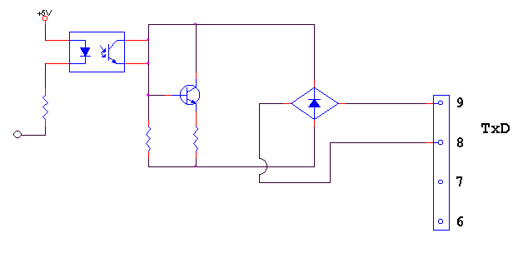

3. Rs-422 Serial Interface (Option)

RS-422/485 serial interface is more stable for electric noise effect compare with other communication method, using electric current difference.

But, install isolated place from Power cable or other electric cables and wires, and please use shielded cable for better performance.

Recommendable communication distance is about 1.2km.

3-1. Connection

**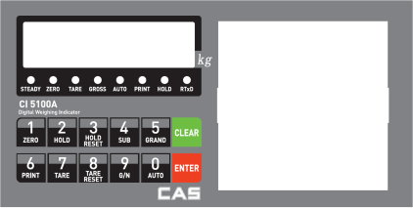- RS-422/RS-485 Connection Diagram -**

**\*\*\*\* Please refer to the PCI Card of Converter (RS-422) manual for computer RS-422 and/or RS-485 line PIN numbers.**

**Computer**



**Indicator**

TXD+ 6.RXD+

TXD- 7.RXD-

RXD+ 8.TXD+

RXD- 9.TXD-

3-2. Signal Format **(As Same as “Rs-232C Serial interface)**

①. Type : EIA-RS-232C

②. Communication Method : Half-Duplex, Full Duplex, Asynchronous

③. Serial Baud Rate : Selectable

④. Data Bit : 8(No Parity mode, only)Bit.

⑤. Stop Bit : 1

⑥. Parity Bit : Non, Even, Odd (Selectable)

⑦ Code : ASCII

3-3. Data Protocol (Data Format 1. – Total 18byte) **- As same as “Rs-232c Serial Interface**

|  |  |  |  |  |  |  |  |  |  |  |  |  |
| --- | --- | --- | --- | --- | --- | --- | --- | --- | --- | --- | --- | --- |
|  |  | , |  |  | , |  |  |  | K | g | CR | LF |

Header1 Header2 Data(8) unit

3-4. Data Protocol (Format 2 – Total 22byte) **- As same as “Rs-232c Serial Interface**

|  |  |  |  |  |  |  |  |  |  |  |  |  |  |  |
| --- | --- | --- | --- | --- | --- | --- | --- | --- | --- | --- | --- | --- | --- | --- |
|  |  | , |  |  | , |  |  | , |  |  | K | g | CR | LF |

Lamp DATA(8) Blank

Header1 Header2 ID No. unit

**▶ COMMAND MODE**

**1. READ COMMAND [Start(STX**  **), End(ETX**  **), Succeed(ACK**  **), Failed(NAK**  **)]**

|  |  |  |
| --- | --- | --- |
| **RxD & TxD** | **Transfer & Response display** | **Command** |
| **PC🡪Indicator Format** | **(ASCII)**  **(HEX)** | Date Data |
| **Response from Indicator** | **(ASCII)**  **(HEX)** |

|  |  |  |
| --- | --- | --- |
| **PC🡪Indicator Format** | **(ASCII)**  **(HEX)** | Time Data |
| **Response from Indicator** | **(ASCII)**  **(HEX)** |

|  |  |  |
| --- | --- | --- |
| **PC🡪Indicator Format** | **(ASCII)**  **(HEX)** | Serial No. |
| **Response from Indicator** | **(ASCII)**  **(HEX)** |

|  |  |  |
| --- | --- | --- |
| **PC🡪Indicator Format** | **(ASCII)**  **(HEX)** | Code No. |
| **Response from Indicator** | **(ASCII)**  **(HEX)** |

|  |  |  |
| --- | --- | --- |
| **PC🡪Indicator Format** | **(ASCII)**  **(HEX)** | Part No. |
| **Response from Indicator** | **(ASCII)**  **(HEX)** |

|  |  |  |
| --- | --- | --- |
| **PC🡪Indicator Format** | **(ASCII)**  **(HEX)** | TARE weight value |
| **Response from Indicator** | **(ASCII)**  **(HEX)** |

|  |  |  |
| --- | --- | --- |
| **PC🡪Indicator Format** | **(ASCII)**  **(HEX)** | Current Weight value |
| **Response from Indicator** | **(ASCII)**    **(HEX)** |
| Remark | **STX(1) ID(2) Command(4) Status1(2) Status2(2) Symbol(1)**  **Weight (Include decimal point)(7) Unit(2) ACK(1) ETX(1)**  **= Total 23 BYTE** |

|  |  |  |
| --- | --- | --- |
| **PC🡪Indicator Format** | **(ASCII)**  **(HEX)** | Sub-Total Data |
| **Response from Indicator** | **(ASCII)**  **(HEX)** |
| Remark | **STX(1) ID(2) Command(4) P/N(2) Code(6) Sub-Total times(6)**  **Sub-Total Weight(8) ACK(1) ETX(1) = Total 31 BYTE** |

|  |  |  |
| --- | --- | --- |
| **PC🡪Indicator Format** | **(ASCII)**  **(HEX)** | Grand-Total Data |
| **Response from Indicator** | **(ASCII)**  **(HEX )** |
| Remark | **STX(1) ID(2) Command(4) P/N(2) Code(6) Grand-Total times(6)**  **Grand-Total Weight(10) ACK(1) ETX(1) = Total 33 BYTE** |

|  |  |  |
| --- | --- | --- |
| **PC🡪Indicator Format** | **(ASCII)**  **(HEX)** | Weighing Condition |
| **Response from Indicator** | **(ASCII)**  **(HEX)** |

|  |  |  |
| --- | --- | --- |
| **PC🡪Indicator Format** | **(ASCII)**  RCWD.bmp **(HEX)** | Memorized Data |
| **Response from Indicator** | **(HEX)** |
| Remark | **STX(1) ID(2) Command(4) Date(6) Time(6) P/N(2) Code(6)**  **Sub-Total times(6) Tare(6) Current Weight(6)**  **Grand-Total Weight(6) ACK(1) ETX(1) = Total 53 BYTE** |

**2. WRITE COMMAND [Start(STX**  **), End(ETX**  **), Succeed(ACK**  **), Failed(NAK**  **)]**

|  |  |  |
| --- | --- | --- |
| **RxD & TxD** | **Transfer & Response display** | **Command** |
| **PC🡪Indicator Format** | **(ASCII)**  **(HEX)** | TARE input |
| **Response from Indicator** | **(ASCII)**  **(HEX)** |

|  |  |  |
| --- | --- | --- |
| **PC🡪Indicator Format** | **(ASCII)**  **(HEX)** | TARE RESET |
| **Response from Indicator** | **(ASCII)**  **(HEX)** |

|  |  |  |
| --- | --- | --- |
| **PC🡪Indicator Format** | **(ASCII)**  **(HEX)** | ZERO input |
| **Response from Indicator** | **(ASCII)**  **(HEX)** |

|  |  |  |
| --- | --- | --- |
| **PC🡪Indicator Format** | **(ASCII)**  **(HEX)** | Print input |
| **Response from Indicator** | **(ASCII)**  **(HEX)** |

|  |  |  |
| --- | --- | --- |
| **PC🡪Indicator Format** | **(ASCII)**  WSPR.bmp **( HEX)** | Sub-Total Print |
| **Response from Indicator** | **(ASCII)**  **(HEX)** |

|  |  |  |
| --- | --- | --- |
| **PC🡪Indicator Format** | **(ASCII)**  **(HEX)** | Grand-Total Print |
| **Response from Indicator** | **(ASCII)**  **(HEX)** |

|  |  |  |
| --- | --- | --- |
| **PC🡪Indicator Format** | **(ASCII)**  **(HEX)** | Date setting |
| Remark | STX(1) ID(2) **Command**(4) Date(6) ETX(1) |
| **Response from Indicator** | **(ASCII)**  **(HEX)** |
| **PC🡪Indicator Format** | **(ASCII)**  **(HEX)** | Time setting |
| Remark | STX(1) ID(2) **Command**(4) Time(6) ETX(1) |
| **Response from Indicator** | **(ASCII)**  **(HEX)** |

|  |  |  |
| --- | --- | --- |
| **PC🡪Indicator Format** | **(ASCII)**  WSNO.bmp **(HEX)** | Serial No. Change |
| Remark | STX(1) ID(2) **Command**(4) S/N(6) ETX(1) |
| **Response from Indicator** | **(ASCII)**  **(HEX)** |

|  |  |  |
| --- | --- | --- |
| **PC🡪Indicator Format** | **(ASCII)**  **(HEX)** | Part No. Change |
| Remark | STX(1) ID(2) **Command**(4) **P/N** (2) ETX(1) |
| **Response from Indicator** | **(ASCII)**  **(HEX)** |

|  |  |  |
| --- | --- | --- |
| **PC🡪Indicator Format** | **(ASCII)**  **(HEX)** | Code No. Change |
| Remark | STX(1) ID(2) **Command**(4) Code(6) ETX(1) |
| **Response from Indicator** | **(ASCII)**  **(HEX)** |

|  |  |  |
| --- | --- | --- |
| **PC🡪Indicator Format** | **(ASCII)**  **(HEX)** | Hold input |
| **Response from Indicator** | **(ASCII)**  **(HEX)** |

|  |  |  |
| --- | --- | --- |
| **PC🡪Indicator Format** | **(ASCII)**  **(HEX)** | Hold RESET |
| **Response from Indicator** | **(ASCII)**  **(HEX)** |

|  |  |  |
| --- | --- | --- |
| **PC🡪Indicator Format** | **(ASCII)**  **(HEX)** | Sub-Total Data Clear |
| **Response from Indicator** | **(ASCII)**  **(HEX)** |

|  |  |  |
| --- | --- | --- |
| **PC🡪Indicator Format** | **(ASCII)**  **(HEX)** | Grand-Total Data Clear |
| **Response from Indicator** | **(ASCII)**  **(HEX)** |

|  |  |  |
| --- | --- | --- |
| **PC🡪Indicator Format** | **333제목 없음1(ASCII)**  **3212222 (HEX)** | “Auto key” input |
| **Response from Indicator** | **56565(ASCII)**  **123 (HEX)** |

|  |  |  |
| --- | --- | --- |
| **PC🡪Indicator Format** | **5555(ASCII)**  **1112222 (HEX)** | “Manual key” input |
| **Response from Indicator** | **4444(ASCII)**  **제목 없음2 (HEX)** |

4. Analogue Output (0~10V / Option)

This Option card converts weight value to Analog Voltage output(0~10V) and transfers to external devices(Recorder, P.L.C), controlled by voltage output.

4-1. Specification

- Output Valtage : 0~10V DC output

- Accuracy : More than 1/1,000

**※As we convert Digital signal(1/30,000 accuracy) to Analogue, so the accuracy will be lower than Digital signal**

4-2. Circuit Diagram and Pint Connection

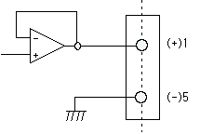 콘넥터1 : HI(+), 5 : (-)

**9pin D-sub Female connector**

※ This Voltage output is proportioned on weight calibration and outputs 0~10V.

4-3. Adjustment

This output is adjusted as when the weight is “Zero”, output is 0V and When the weight is “Full capacity”, output is 10V.

If you need additional adjustment, please adjust with “VR1(Zero)”, “VR2(Span) on the Analog Output PCB.

**※ Remark**

This Analog option card converts Displayed weight value(Micro-process data) to analog value on D/A Converter(Digital to Analog converter)

This D/A Converter has Max. 1/4,000 accuracy, so this output is not suitable for high accuracy application, like more than 1/3,000.

For 0~5VDC or 1~5VDC analog output, please inform when you inquiry.

4-4. Output Test

Enter to “TEST” mode and select TEST mode 2(key test).

If you press No.1(0V) / No.2(2.5V) / No.3(5V) / No.4(7.5V) / No.5(10V) will be output.

**5.** Analogue Output (4~20mA / Option)

This Option card converts weight value to Analog Voltage output(4~20mA) and transfers to external devices(Recorder, P.L.C), controlled by voltage output.

4-1. Specification

- Output Voltage : 4~20mA output (Max.2~22mA)

- Accuracy : More than 1/1,000

- Temperature Coefficient : 0.01%/℃

- Max. Loading Impedance : Max. 500Ω

**※As we convert Digital signal(1/30,000 accuracy) to Analogue, so the accuracy will be lower than Digital signal**

4-2. Circuit Diagram and Pint Connection

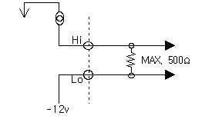 콘넥터1 : HI(+), 5 : (-)

**9pin D-sub Female connector**

※ “LO” terminal is not a “GND”, so this “LO” terminal do not be connected with other “GND” terminal on other devices.

※ This output is proportioned on weight calibration and outputs 4~20mA.

4-3. Output Adjustment

①. This output is adjusted as when the weight is “Zero”, output is “4mA” and When the weight is “Full capacity”, output is “20mA”.

②. If you need additional adjustment, please adjust with “VR1(Zero)”, “VR2(Span) on the Analog Output PCB.

※ Remark

This Analog option card converts Displayed weight value(Micro-process data) to analog value on D/A Converter(Digital to Analog converter)

This D/A Converter has Max. 1/4,000 accuracy, so this output is not suitable for high accuracy application, like more than 1/3,000.

6**.** BCD Input (Option)

This “BCD interface” option card can be applied on PLC (Programmable Logic Controller), or Score Board applications.

Each Input circuit is isolated with “Photo-Coupler”, from external devices electrically.

6-1. Circuit Diagram

**13**

**25**

**5 4 3 2 1**

**com 40 10 4 1**

**17 16 15 14**

**80 20 8 2**

**BCD Input Value**

**D-Sub 25pin No.**

This Option card can be used for changing Part No. setting from external devices.

7**.** BCD Input (Option)

This “BCD interface” option card can be applied on PLC (Programmable Logic Controller), or Score Board applications.

Each Input circuit is isolated with “Photo-Coupler”, from external devices electrically.

7-1. Circuit Diagram

**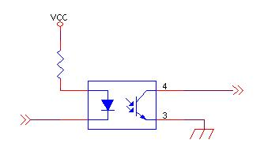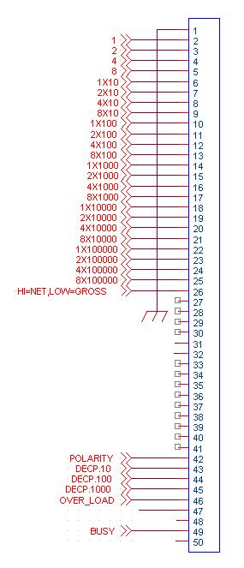**

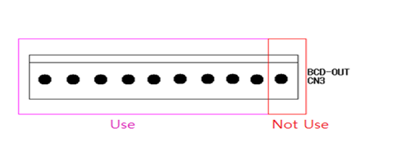

Through this connector, it will be connected with main board.

8**.** Serial Printer Interface (Standard).

This interface can be connected all kinds of serial interface installed printer devices.

But, programmed print format is specialized with our serial printer only.

So, if you use different model, the format can be changed or not printed.

8-1. Printer Specification

1. Interface : Rs-232

2. Protocol : 9600 bps, No Parity, Data(8), Stop(1)

3. Column : 30 Column

4. Printing type : Combination type

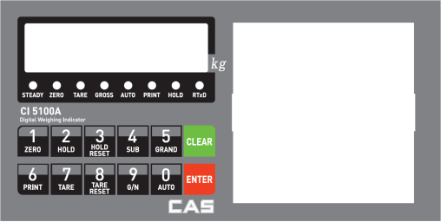 8-2. Pin Connection

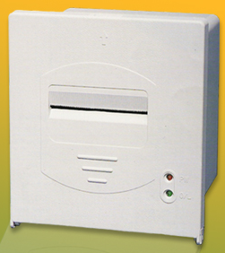

GND ---------------------- GND

TXD ----------------------- RXD

Indicator Serial Printer

8-3. Print Port

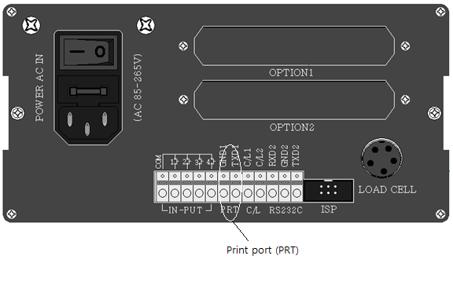

9. Serial Print Format

|  |  |  |  |  |
| --- | --- | --- | --- | --- |
| **Single**  **Print Format** | **제목 없음** |  | **Continuous**  **Print Format**  **Sub-Total**  **Print Format**  **Grand Total**  **Print Format** | **소계총계영문** |

**Chapter 7. Error and Treatment**

1. TEST Mode

|  |  |  |
| --- | --- | --- |
| **TEST Mode No.** | **Contents** | **Detail information** |
| TEST 1. | Analogue TEST mode | This mode is Analogue testing |
| TEST 2. | Keypad TEST mode | This mode is Keypad testing or Analogue Option Card Test  (4~20mA or 0~10v)  - No.1 key : 4mA / 0V output  - No.2 key : 8mA / 2.5V output  - No.3 key : 12mA / 5V output  - No.4 key : 16mA / 7.5V output  - No.5 key : 20mA / 10V output |
| TEST 3. | SET.CAL Mode | This mode is F-Function setting or Calibration setting |
| TEST 4. | Display TEST Mode | Check that display is normal or not |
| TEST 5. | Relay output TEST Mode | If have a relay, check the relay output |
| TEST 6. | External input(Digital Input)TEST Mode | Check that external input is normal or not |
| TEST 7. | Un-Calibrated Analogue TEST Mode | Check the pure analogue value when not calibration |

**※If you installed Analogue Option card, you can test Analogue output test with “TEST 2” mode. (Please check detailed information)**

**Enter to TEST Mode**

**회색.png회색.png **

**회색.png회색.png**

Turn on the power with pressing 3.jpgkey.

Then, display will show **,** then press C.jpg, and then press No. key and move to the certain TEST mode.

TEST

**Exit from TEST Mode**

Press C.jpg key to exit from each TEST mode.

Then, display will show

TEST

※ Under TEST 3.mode, press 8.jpg key to exit **.**

SET-CAL

TEST

2. Error and Treatment

2-1. Load Cell Installation

|  |  |  |  |
| --- | --- | --- | --- |
| **Error** | **Cause** | **Treatment** | **Remark** |
| Weight Value is  unstable | 1). Load cell broken  2). Load cell isolation  resistance error  3). Weighing part  touches other devices or some weight is on the weighing part  4). Summing Board  Error | 1). Measure input/output resistance of Load cell.  2). Measure Load cell isolation resistance  3) Check attach point with other devices. | 1).Input Resistance of “EX+” and “EX-“ is about 350Ω~450Ω.  2). Output Resistance of “EX-“ and “EX+” is about 350Ω.  3). Isolate Resistance is more than 100Ω |
| Weight Value is increased regular rate, but not return to “Zero” | 1). Load cell Error  2). Load cell connection Error | 1). Check Load cell connection  2). Measure Load cell Resistance |  |
| Weight Value is increased to under Zero | Load cell Output wire (SIG+, SIG-) is switched | Make wire correction |  |
| “UN PASS” display | Load cell broken or Indicator connection Error | Load cell Check  Load cell connection Check |  |
| Power was “ON” when some weight is on the load cell? | Remove weight on the Load cell |  |
| “OL” or “UL” display | 1). Load cell broken or Indicator connection Error  2). Loading over than Max. Capacity | 1). Load cell Check  2). Load cell connection Check  3). Remove over loaded weight |  |

2-2. Calibration Process

|  |  |  |
| --- | --- | --- |
| **Error** | **Cause** | **Treatment** |
| Err 01 | When Max.capacity/digit value is over 20.00 | Re-input the Max. Capacity, less than 20.00  (Max. Capacity / Digit) |
| Err 04 | Standard weight value is over than Max. Capacity | Re-input Standard weight value with Number keys, under Max. Capacity |
| Err 05 | Standard weight value is less than 10% of Max. Capacity | Re-input Standard weight value with Number keys, more than 10% of Max. Capacity |
| Err 06 | 1. Amp. Gain is too big  2. Sig+ and Sig- wire connection error  3. Test weight is not loaded | Check standard weight’s weight with set value.  If there is difference between set value and real weight, please re-input the value  (set value is too small) |
| Err 07 | 1. Amp. Gain is too small  2. Sig+ and Sig- wire connection error  3. Test weight is not loaded | Check standard weight’s weight with set value.  If there is difference between set value and real weight, please re-input the value  (set value is too big) |
| Err 08 | Under “F-function” model, set value is “N.A” | Check the correct value and re-input |
| Err 09 | When Y.Y has the value between 3.9 ~ 9.9 at Y.YXXXX as Span value,  If standard weight value is less than 10% of Max. Capacity | Change the Max.capacity/digit value  (Ex: digit 01 🡪 05) |
| Err A | When there is continuous vibration on the weighing part,, indicator can not process calibration any more. | - Find vibration cause and remove  - Load cell check  - Load cell cable and connecting condition check |

|  |  |
| --- | --- |
| **WARRANTEE CETIFICATION** | |
| This product is passed “CAS”s strict quality test.  If there is defect of manufacturing or abnormal detection within warrantee period, please contact our Agent or Distributor with this Warrantee certificate.  Then, we will repair or replace free of charge. | |
| **WARRANTEE CLAUSE** | |
| **1. The Warrantee period, we can guarantee, is one(1) year from your purchasing date**  **2. Warrantee Exception Clause**  - Warrantee period is expired.  - Any kinds of Mal-function or defection caused by Modification or Repair without CAS’s permission.  - Any kinds of Mal-function, Defection, or External damage, caused by operator  - Any kinds of Mal-function, Defection, caused by using spare part from Non-Authorized Distributor or Agent.  - Any kinds of Mal-function, Defection, caused by not following Warnings or Cautions mentioned on this manual.  - Any kinds of Mal-function, Defection caused by “Force Majeur”, like Fire, Flood.  - Without presentation of this **“Warrantee Certification”.**  **3. Other**  - Any kinds of “Warrantee Certification” without authorized Stamp is out of validity  . | |
| **Product** | Digital Weighing Indicator |
| **Model** | CI 5100A |
| **Serial No.** |  |
| AUTHORIZED  STAMP |  |